2025 TERM 1 MZIMBA NORTH DISTRICT EXAMINATIONS
MATHEMATICS FORM 2
(100 Marks)
Subject No: J131
11th December, 2025 Time Allowed: 2 hours
8:00 am to 10:00 am
Instructions:
Question Number | Tick if answered | Do not write in these columns
1
2
3
4
5
6
7
8
9
10
11
12
13
14
15
16
17
18
19
20
- This paper contains 12 printed pages. Please check.
- Write your name in full and class in spaces provided on top of each page.
- This paper contains 20 questions. Answer all the questions in the spaces provided.
- Use of electronic calculators is allowed.
- The maximum number of marks for each answer is indicated against each question.
- Show all your working clearly
- In the table provided on this page, tick against the question number you have answered.
- Hand in your paper to the invigilator when time is called to stop writing.

ANSWER ALL QUESTIONS
1.(a) Simplify $2k-7f-4(2k-3f)$ (3 Marks)

(b) Evaluate 1011₂ + 405₁₀ leaving your answer to base 10 (4 Marks)

2. (a) Expand $(3d-2)$² (3 Marks)

(b) Make n the subject of the formula $T=a+\left(n-1\right)d$ (3Marks)

3. Show that 3, 4 and 5 are Pythagorean triple (3 Marks)

4. The following shows length in cm of samples of 50 seedlings found in a certain seed bed.
2 | 7 | 4 | 3 | 2 | 6 | 5 | 5 | 4 | 6
5 | 7 | 3 | 5 | 4 | 7 | 3 | 4 | 3 | 2
4 | 6 | 4 | 7 | 5 | 3 | 5 | 5 | 6 | 3
6 | 5 | 7 | 6 | 6 | 4 | 6 | 6 | 5 | 7
5 | 4 | 2 | 7 | 4 | 3 | 6 | 5 | 5 | 7

- Construct a frequency table. (4 marks)

(b) Use it to calculate the mean length of the seedlings.
(3 Marks)

5 Figure 1 below shows a rectangle PQRS
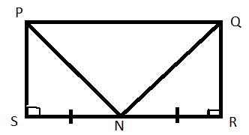
If SN=RN, show that triangle PSN is congruent to triangle QRN (4 Marks)

6. Factorize $6m$ ²$+13m+6$ (4 Marks)

7. The n^{th} term of a sequence is $\frac{1}{n+2}$ and the last term is 0.1. Find the number of terms of the sequence
(5 Marks)

- Given the equation $5x-y=8.$ Find:
- $y$ intercept (3 Marks)

- Gradient of the equation
(2 Marks)

- A residence plot in town appreciates in value at the rate of 15% per annum. Its current value is k3,500,000. Calculate its value after 2 years (5 Marks)

- Solve the equation $\frac{5x+2}{4}-$ $\frac{3}{2}=\frac{7x+1}{3}$ (5 marks)

11. In the following MN is parallel to PR,angle QPR= 63⁰ and angle MNP= 40⁰
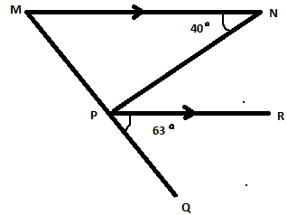
Calculate the size of angle MPN (4 Marks)

12. Solve the following simultaneous equation
$2m-n=4…………..\left(i\right)$
$2m+3n=-4………….(ii)$ (4 Marks)

13. Factorize $3x$ ²$-27$ (4 marks)

14. The sum of the interior angles of a regular convex polygon is $2340°$. Calculate the value of each exterior angle of the polygon.
(5 marks)

15. (a) Figure 3 below shows a quadrilateral MPON.
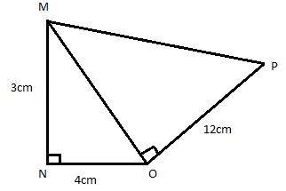
Calculate the length of MP (4 marks)

(b) A family of 6 people uses 30 kg of flour in a month. If 2 visitors joined them for a month, how many kilograms of flour would be required for that month?
(4 marks)

16. The following Venn diagram shows numbers of elements for set M and Q
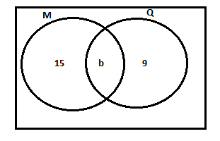
Given that n(MUQ) =34, Find n(M∩Q)
(4 marks)

17. The diagonals of a rhombus are 10cm and 24cm respectively. Calculate the length of the sides of the rhombus (5 marks)

18. Figure 4 below shows a cylindrical steel bar whose length is 7cm and diameter of 4cm.
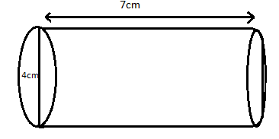
Calculate the volume of the cylindrical steel bar (Take π =3.14), leaving your answer to 2 significant figure.
(4 Marks)

19. Using a ruler and a pairs of compasses only, construct in the same diagram a triangle ABC such that AB = 6cm, AC = 5cm and angle CAB = $60°$ (5 Marks)

20. Table 1 below shows the values of x and y for equation$y=2-x$.
x | -3 | 0 | 2
y |  | 2 | 0
- Complete the table of values for equation $y=2-x$ (1 Marks)
- Using a scale of 2cm to represent 2 unit on both axes, draw the graph of $y=2-x$ on the graph paper provided (3 Marks)
- Using your graph, solve the simultaneous equations for $y=2-x$ and $y=2$ (2 marks)

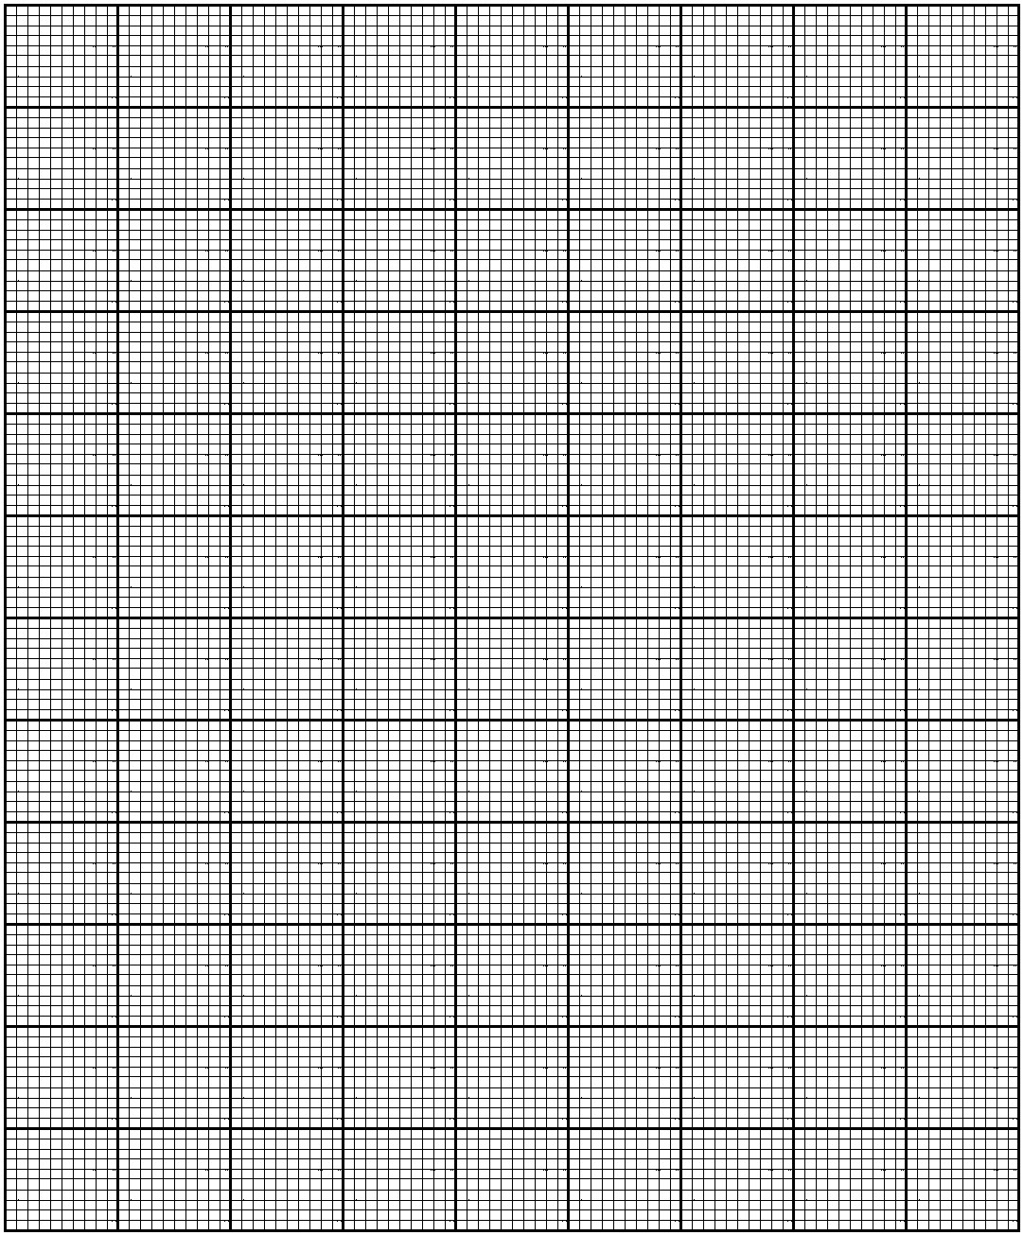
The end of question paper

